**BACHELOR OF SCIENCE**

DEPARTMENT OF

PHYSICS

**Unveiling Market Insights**

**Analysing Spending Behaviour**

**TEAM LEADER**

**DINESH H**

**MEMBERS**

**HARISHRAJ S**

**KAMALAKANNAN S**

**RAGHUL KRISHNA D**

**UNDER GUIDANCE OF**

**MR.YUVARAJ**

# INTRODUCTION

• • Wholesaling or distributing is the sale of goods or merchandise to retailer to industrial, commercial, institutional or other professional businessman to other wholesalers (wholesale businesses) and related subordinated services. In general, it is the sale of goods in bulk to anyone, either a person or an organization, other than the end consumer of that merchandise. Wholesaling is buying goods in bulk quantity, usually directly from the manufacturer or source, at a discounted rate. The retailer then sells the goods to the end consumer at a higher price making a profit.

## Business Requirements

1.Analyzing spending behavior and identifying opportunities for growth can provide crucial market insights for businesses looking to optimize their strategies and increase market share.

**2.Pricing Optimization:** Analyze the relationship between pricing and spending behavior to identify pricing strategies that maximize revenue while maintaining customer satisfaction.

**3.Purchase Patterns:** Analyze the frequency and timing of customer purchases to identify seasonal trends or patterns that can guide inventory management and marketing campaigns.

**4.Competitor Analysis:** Compare your spending behavior data with competitors to understand your market position, pricing strategies, and areas where you can gain a competitive advantage.

## Literature Survey

••To analyze the changing behavior of the customers on various products

••To analyze both professional and non-professional customers by comparing the customer reviews with their profiles

••To conduct customer reviews on getting products

••To provide an overview of social networking sites, behavioral analysis and opinion analysis

••To calculate and compare customer review quality

••To analyze consumer behavior quality.

## Social Or Business Impact

**Social Impact:**

•Personalization and Targeted Marketing: With insights from spending behavior analysis, businesses can personalize marketing efforts and promotions. This targeted marketing approach reduces unnecessary advertising noise and enhances the relevance of promotional messages for consumers.

•Economic Growth and Job Creation: As businesses identify growth opportunities and optimize their strategies, they often experience increased revenue and expansion. This can lead to economic growth and job creation, benefiting local communities and contributing to the overall prosperity.

**Business Impact:**

•Revenue Growth: Leveraging market insights to identify growth opportunities can lead to increased sales and revenue for businesses. Understanding customer preferences and optimizing product offerings can attract more customers and improve customer retention.

•Cost Optimization: Data-driven decision-making allows businesses to allocate resources more efficiently. By identifying underperforming products or unprofitable channels, businesses can optimize costs and improve their bottom line.

**PROJECT FLOW**

* EMPATHY MAP
* BRAINSTROMING MAP
* KPI’s
* REGION WISE DETERGENT PAPER AND GROCERY
* REGION WISE MILK
* CHANNEL WISE FROZEN AND DELICATESSEN
* REGION WISE DELICATESSEN AND DETRGENT PAPER
* CHANNELWISE GROCERY AND DETERGENT PAPER
* REGION WISE DELICATESSEN

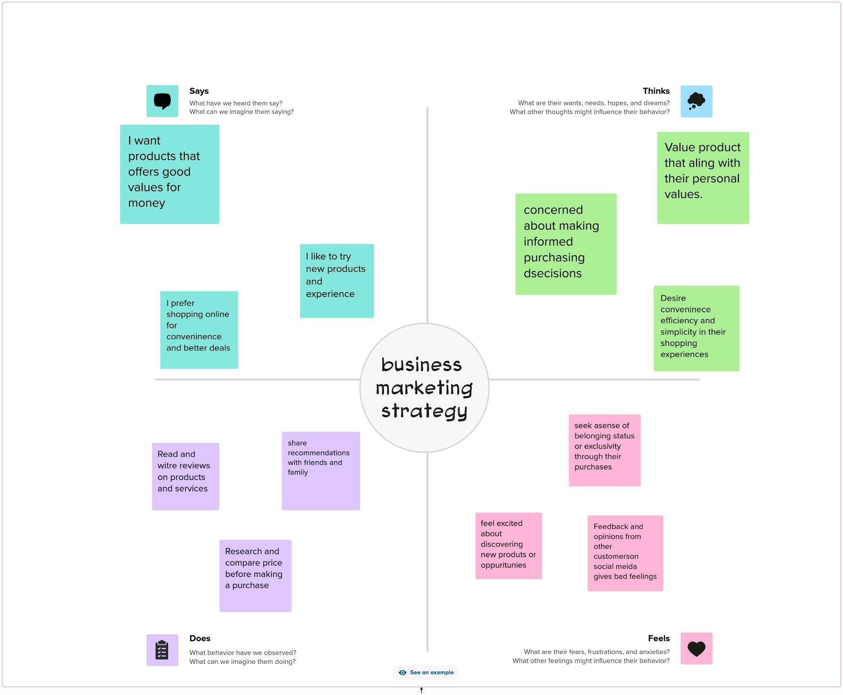

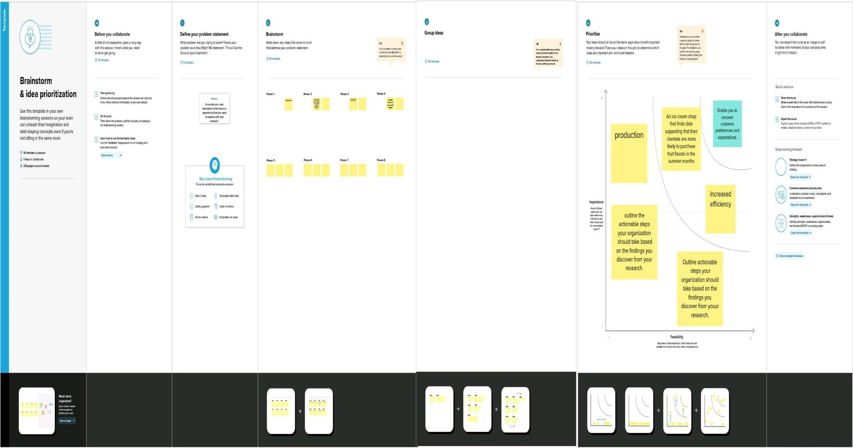

## DATA PRESENTATION

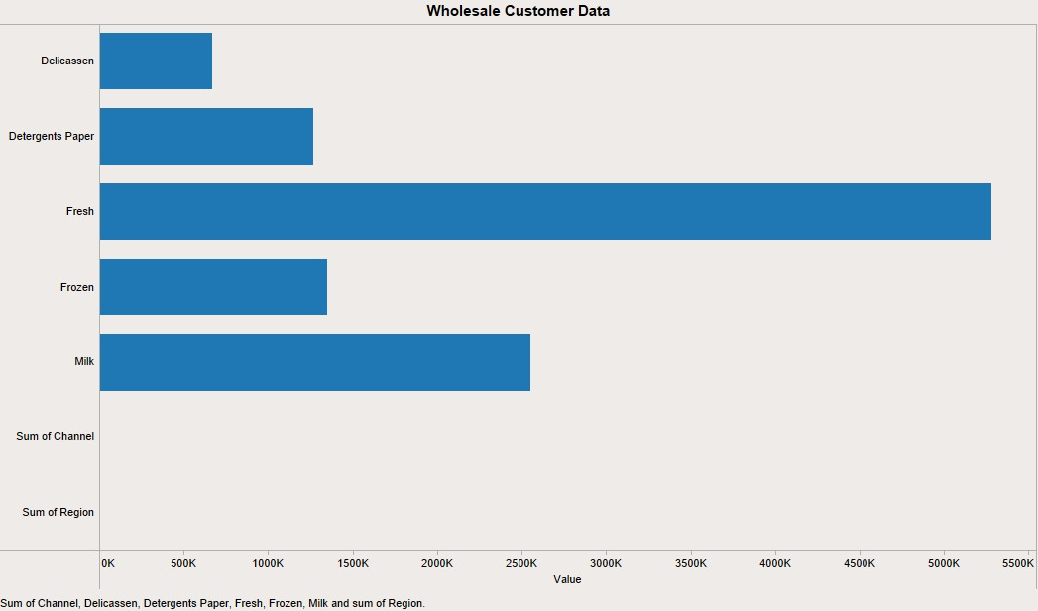

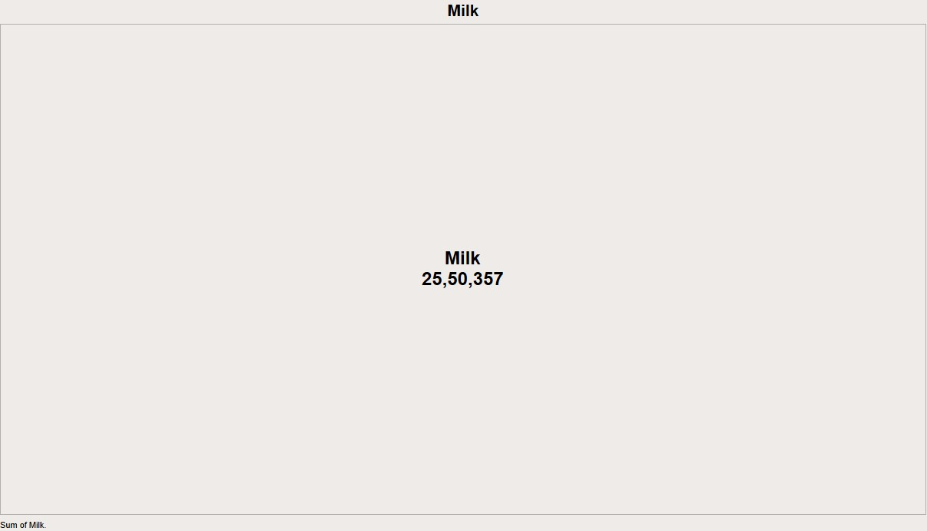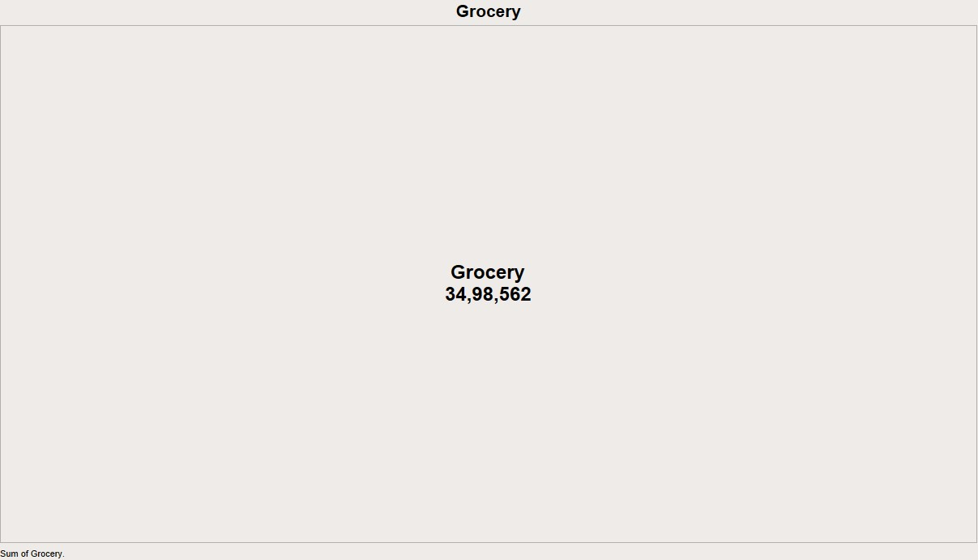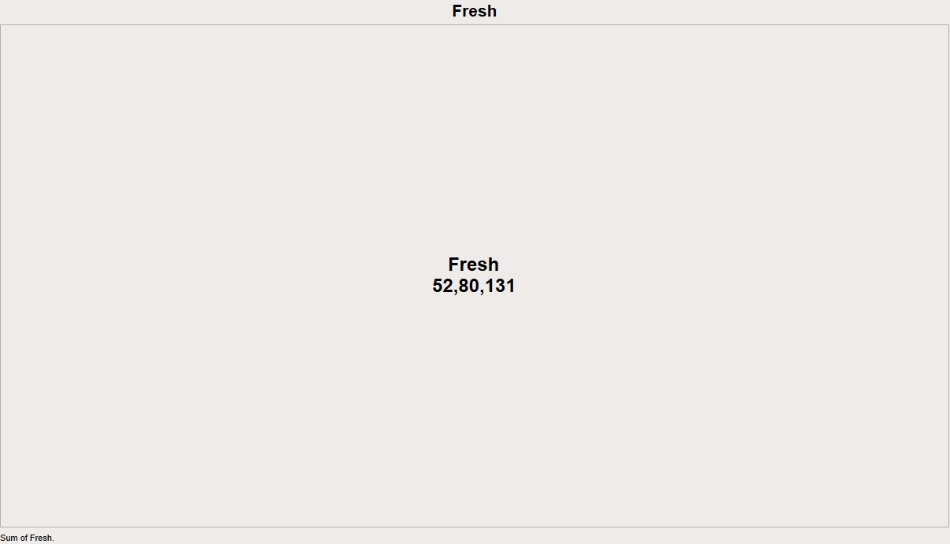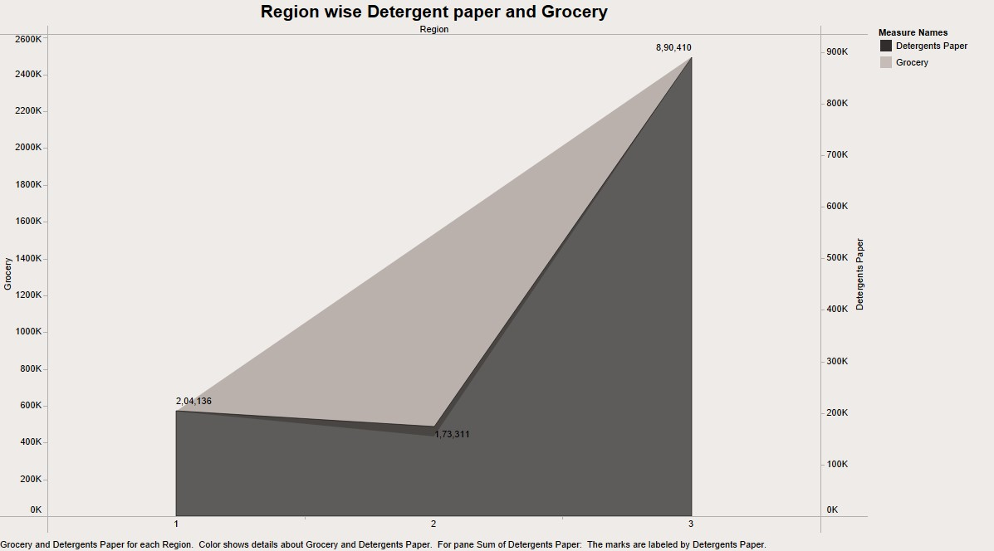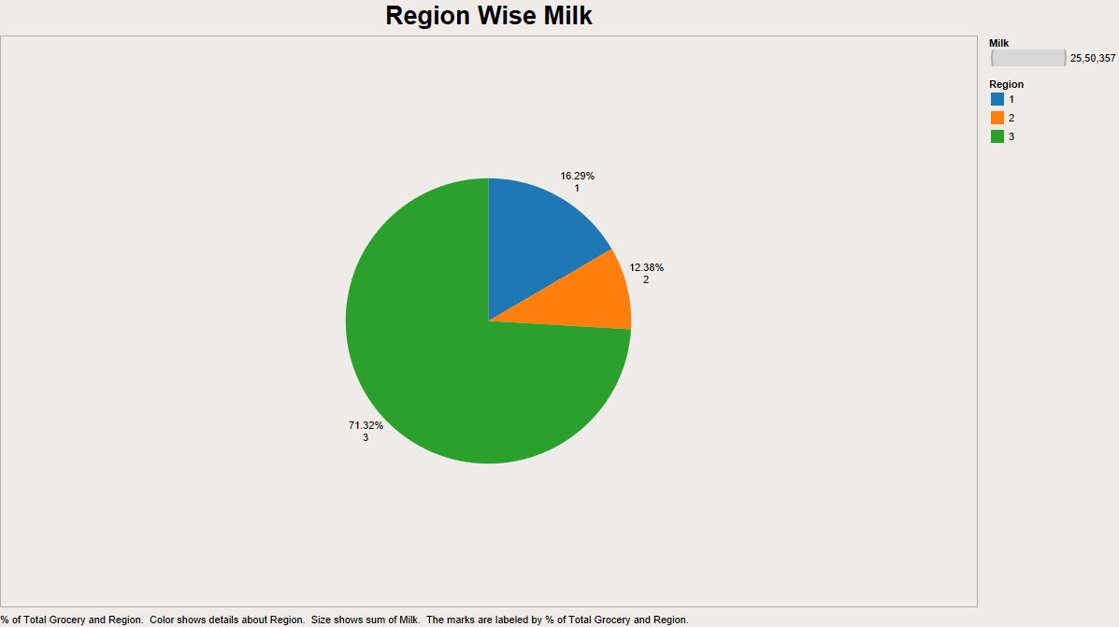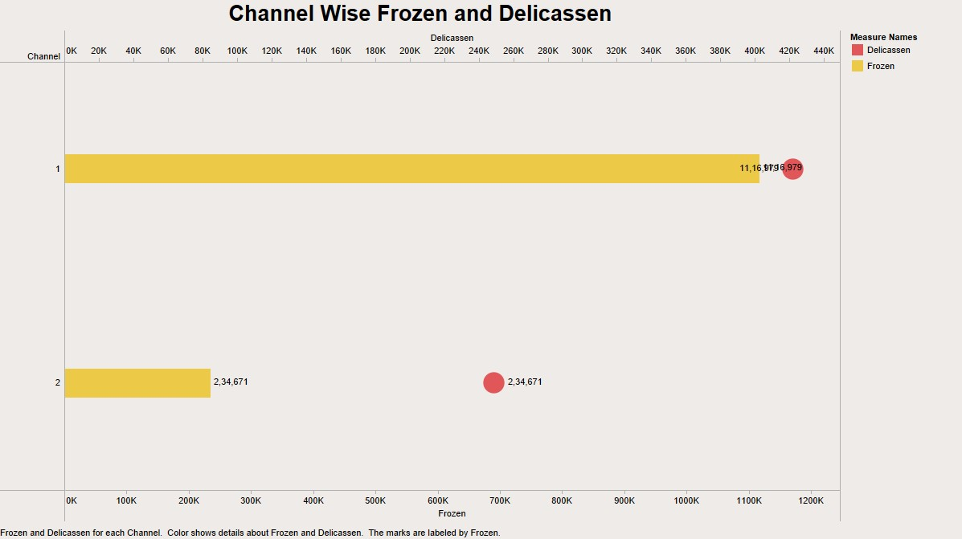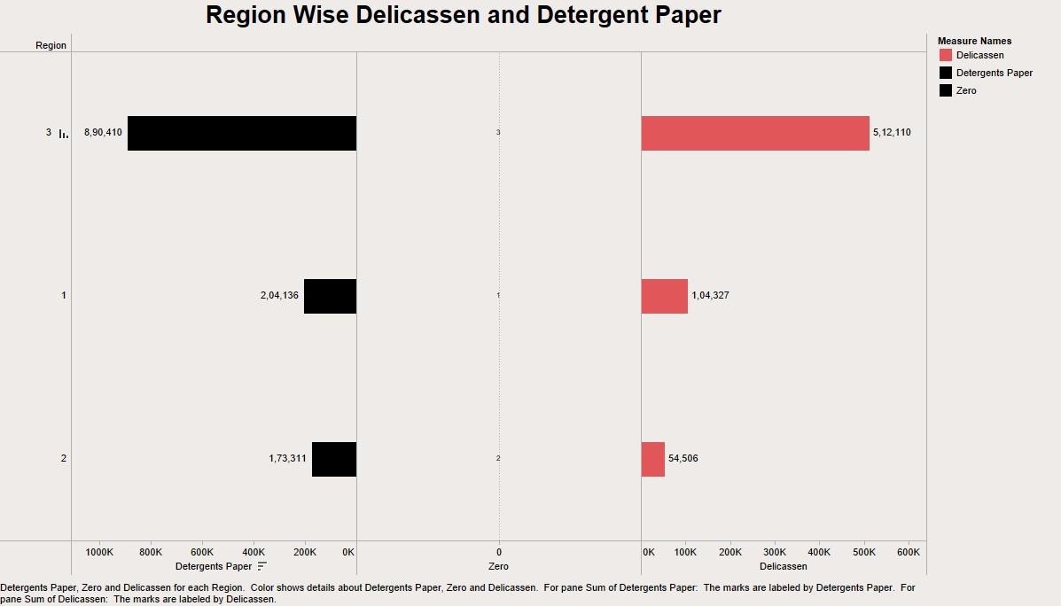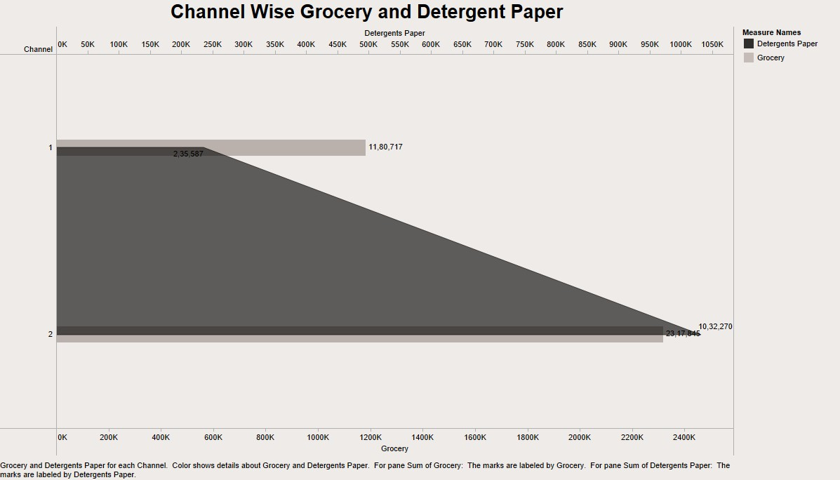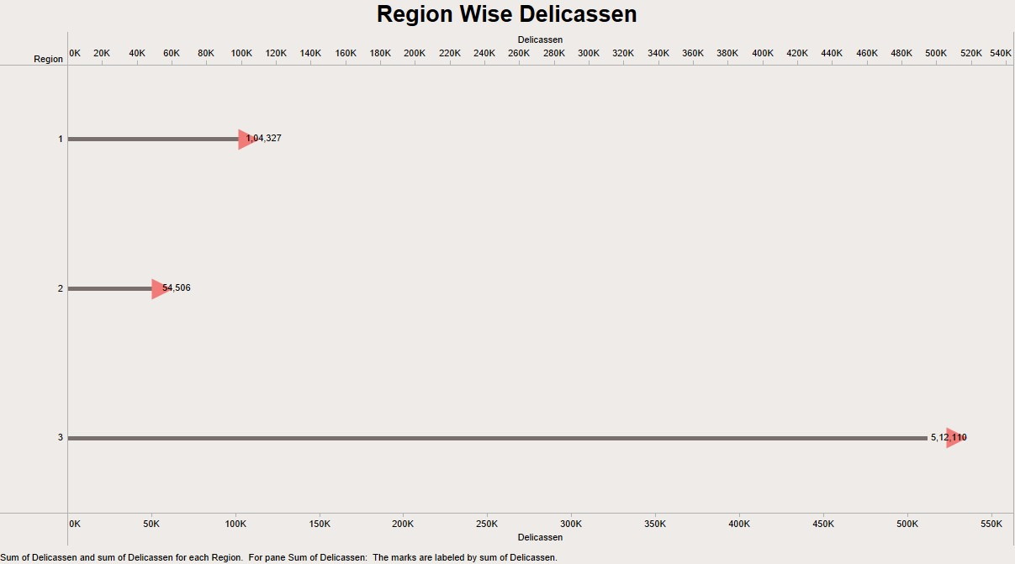

**DASHBOARD**

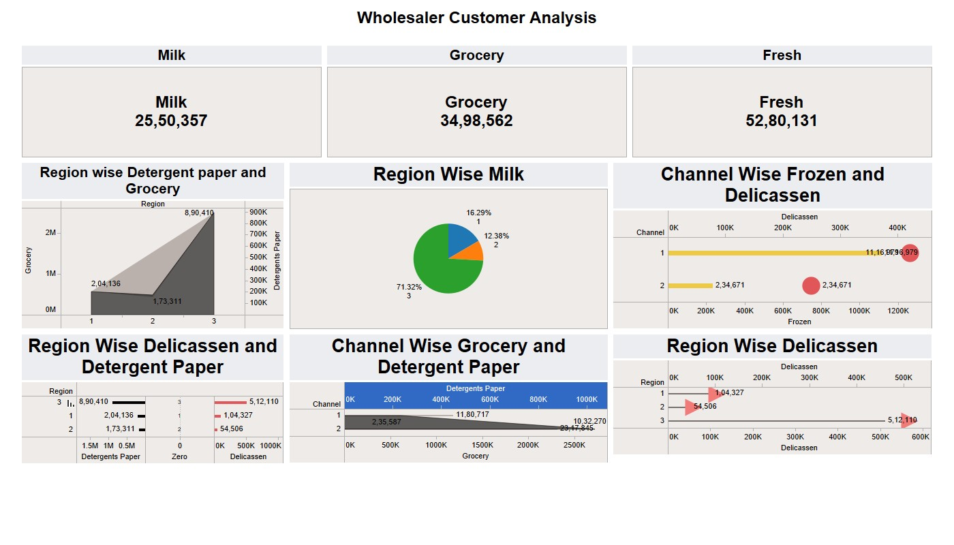

# 

# STORY

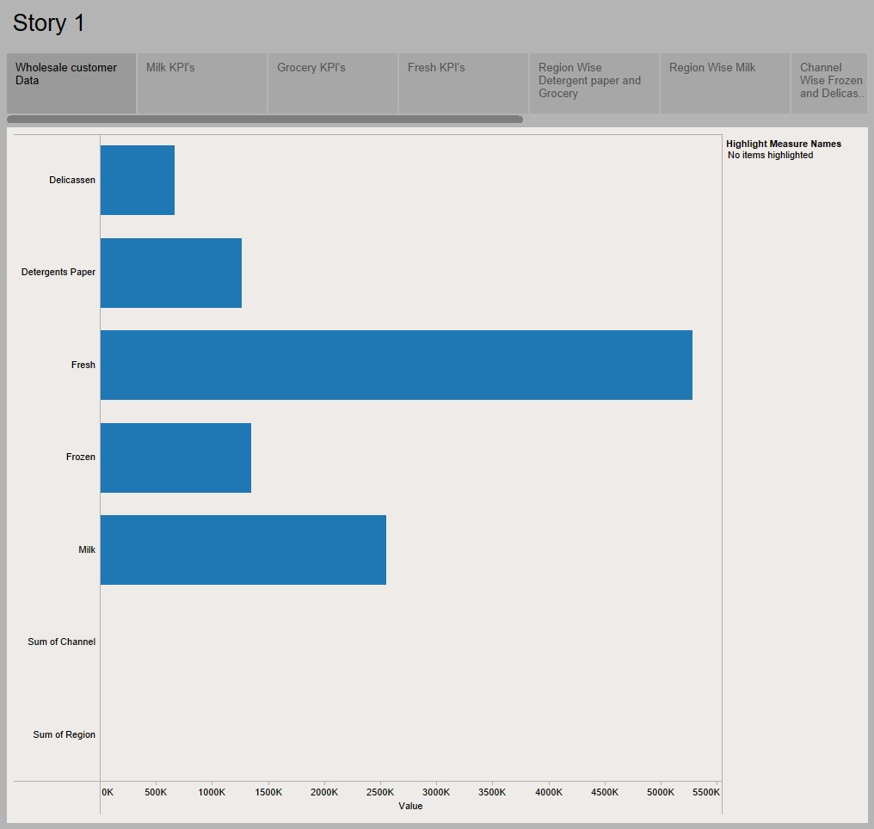

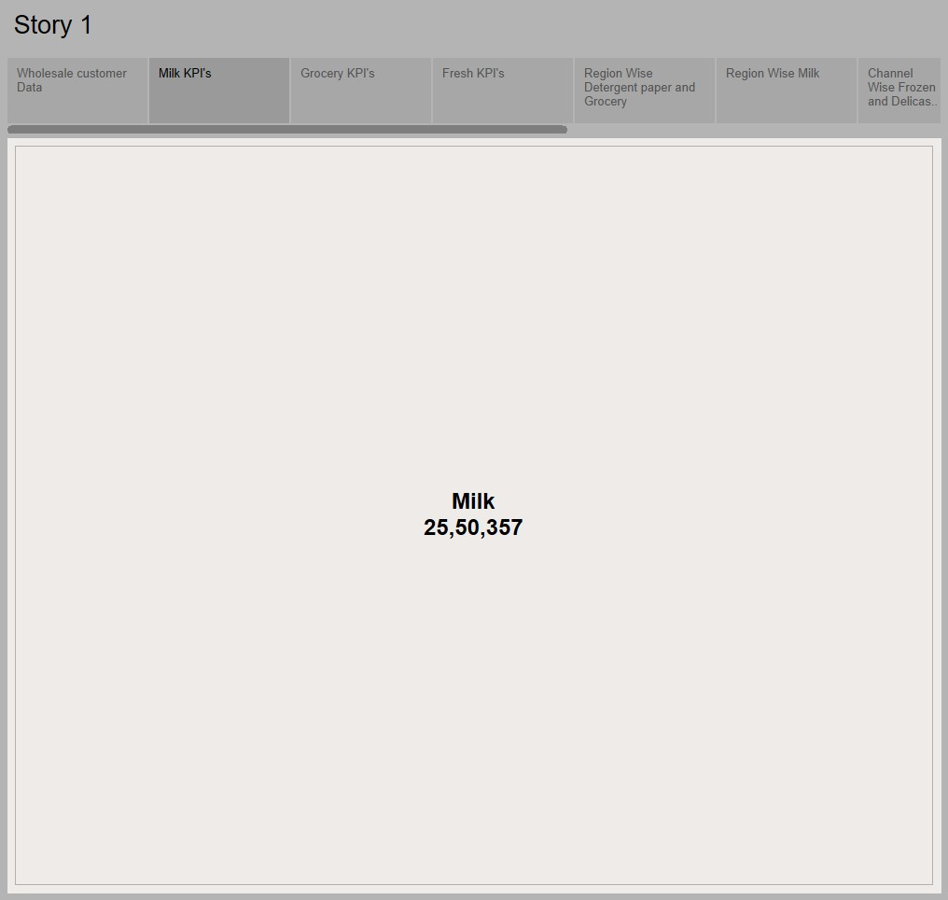

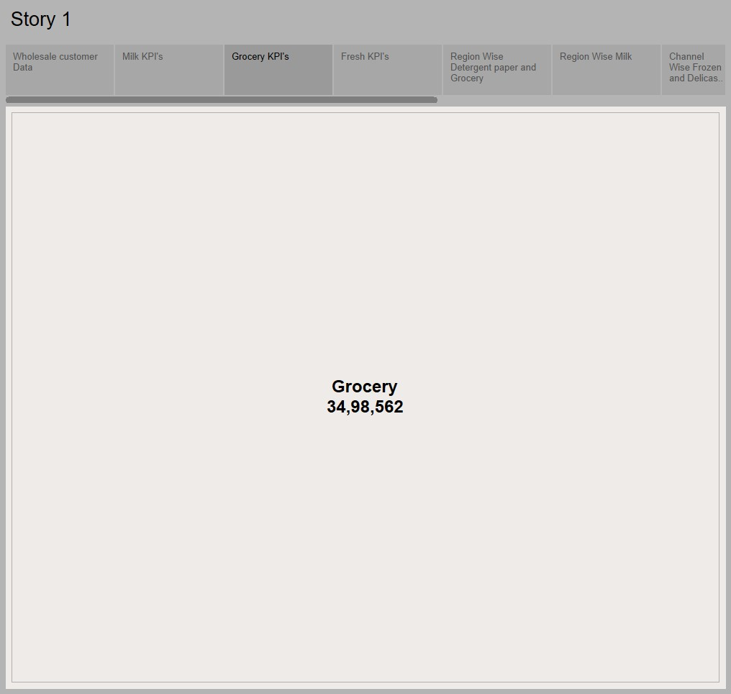

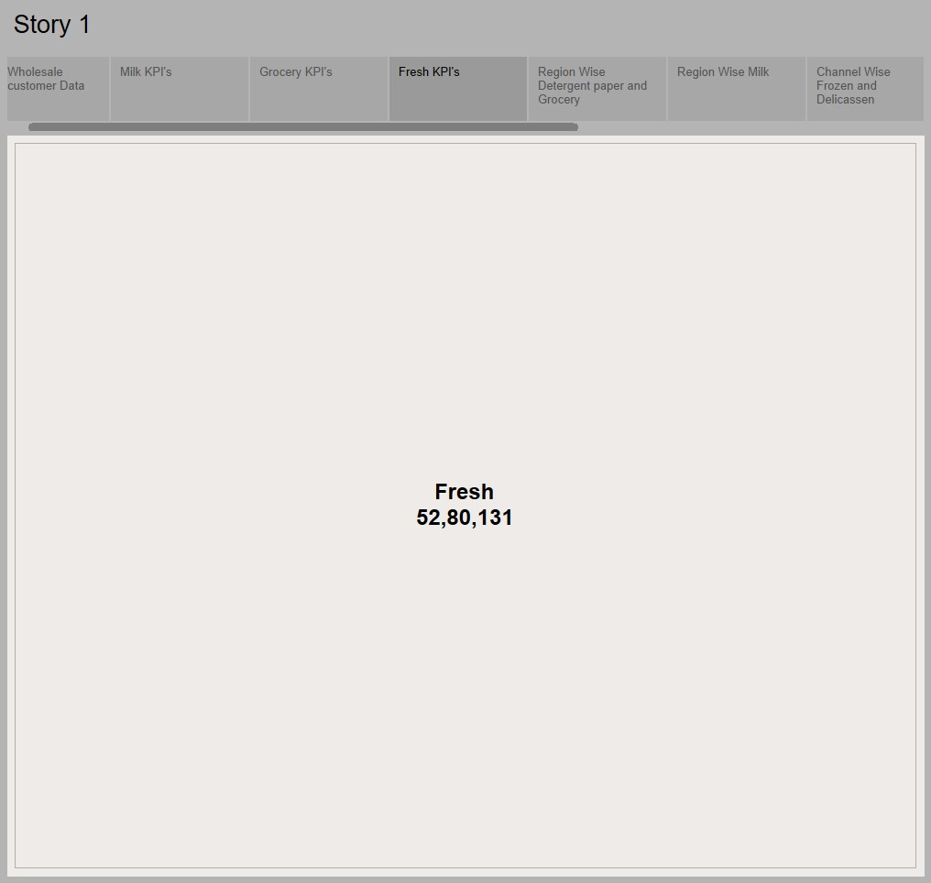

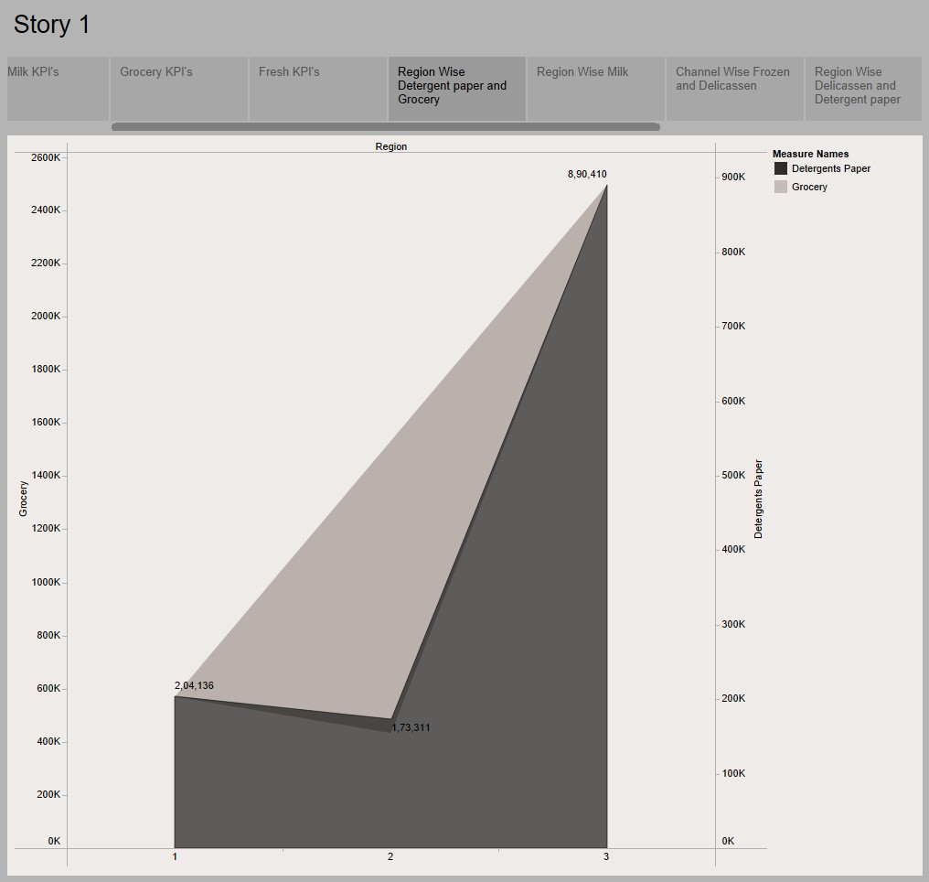

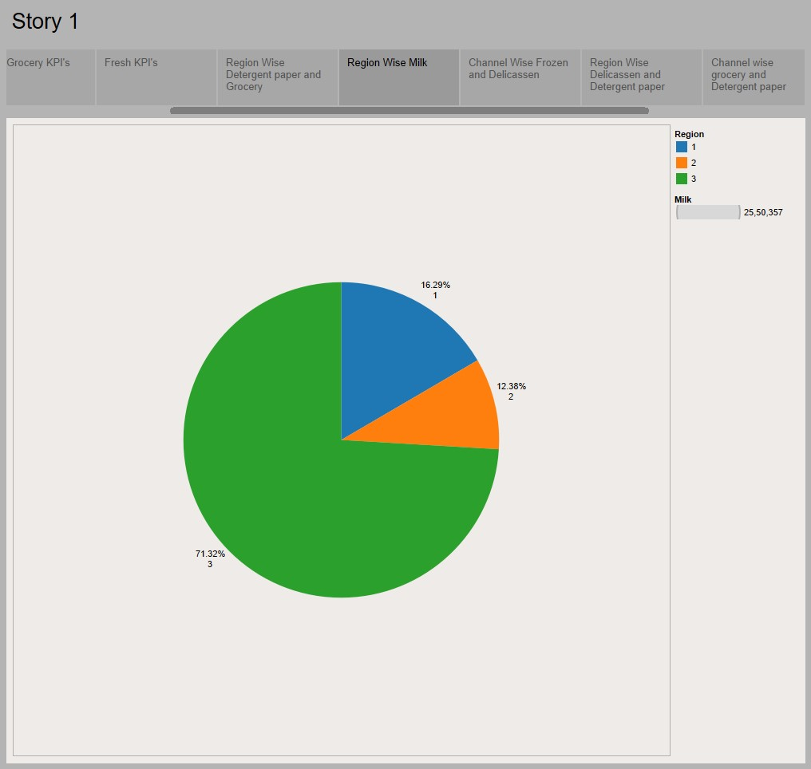

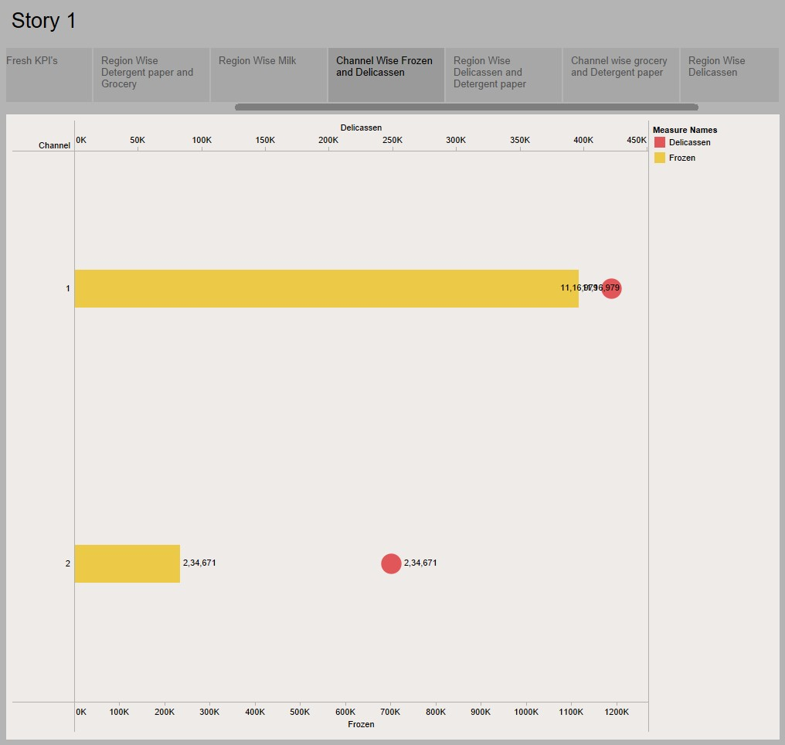

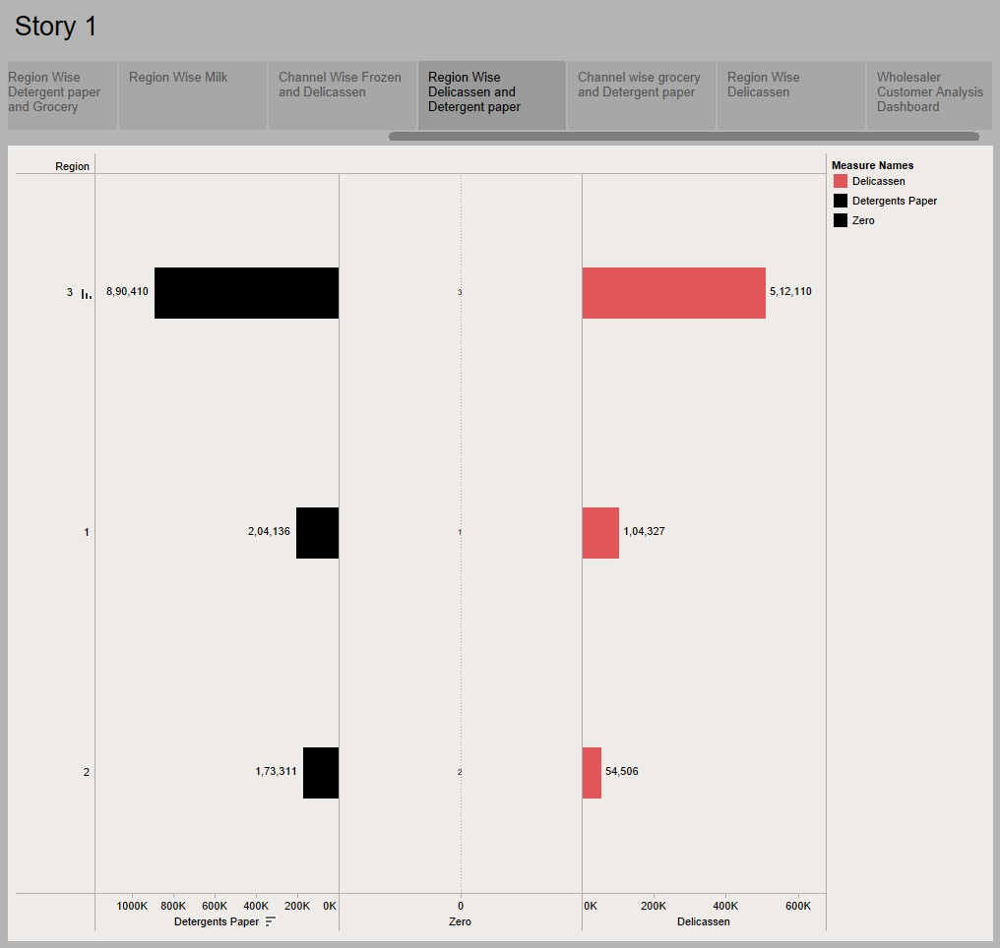

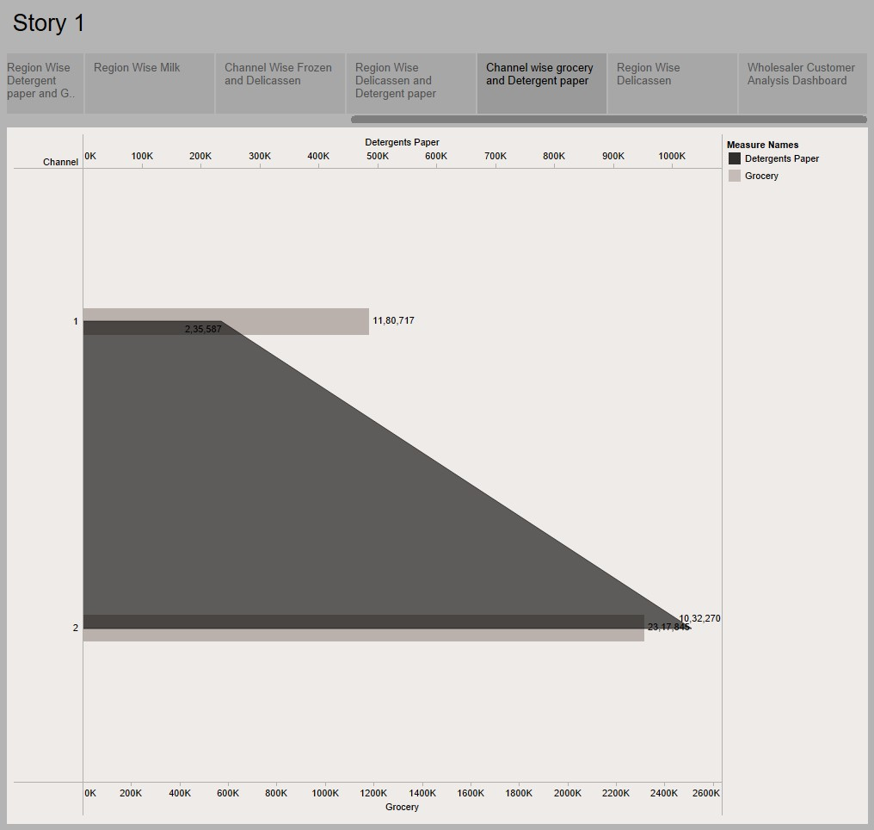

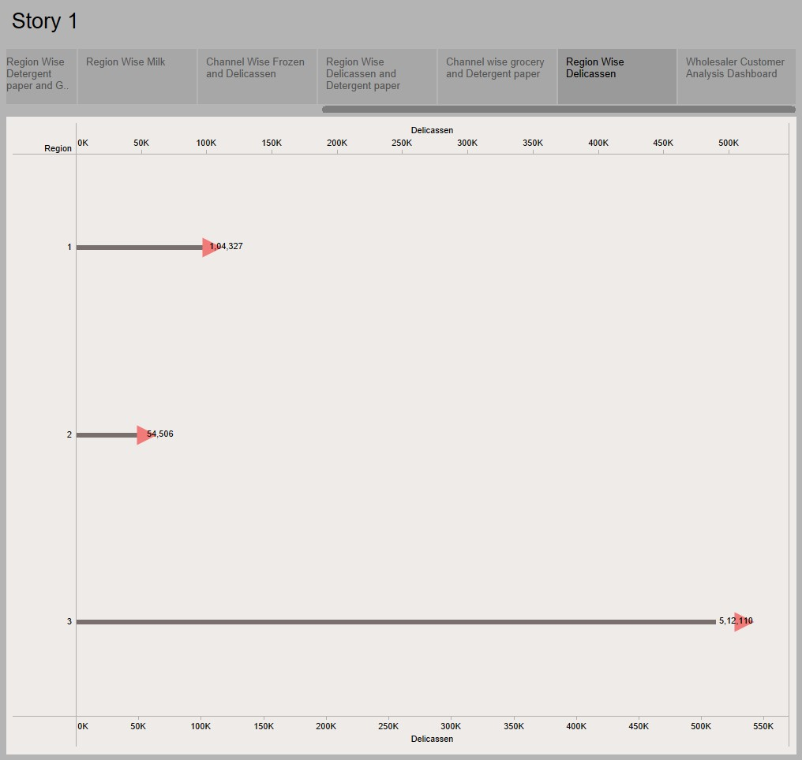

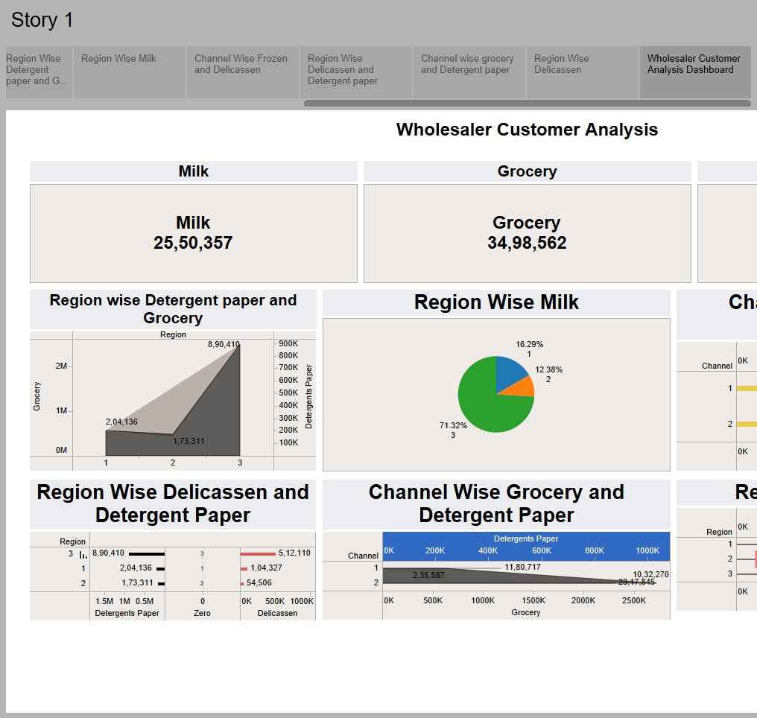

# Advantages of Wholesale

***Wholesale*** refers to the process of buying goods or products in bulk from manufacturers, producers, or distributors, and selling them in smaller quantities to retailers or end consumers. Wholesale offers several merits that make it an advantageous business model. Here are some of the key advantages of wholesale:

1. **Cost Savings**: Wholesale allows businesses to benefit from economies of scale. By purchasing goods in large quantities, wholesalers often receive substantial discounts from manufacturers or suppliers. These cost savings can be passed on to retailers or customers, resulting in competitive pricing and increased affordability.
2. **Increased Profit Margins**: Wholesalers typically purchase goods at lower prices than retailers, enabling them to achieve higher profit margins. By buying products in bulk and selling them in smaller quantities at a higher price, wholesalers can generate significant profits.
3. **Wide Product Range**: Wholesalers typically deal with a wide variety of products from different manufacturers or suppliers. This provides retailers with access to an extensive range of products, allowing them to cater to diverse customer preferences and demands. Wholesalers act as a one-stop shop for retailers, simplifying the procurement process.
4. **Streamlined Supply Chain**: Wholesalers play a crucial role in the supply chain by acting as intermediaries between manufacturers and retailers. They consolidate products from multiple sources, handle inventory management, and ensure timely delivery to retailers. This streamlines the supply chain, reduces logistics complexities, and allows retailers to focus on their core business activities.
5. **Relationship Building**: Wholesalers often develop long-term relationships with manufacturers, suppliers, and retailers. These relationships are built on trust, reliability, and mutual benefits. Wholesalers act as a bridge between producers and retailers, facilitating smooth transactions, fostering collaboration, and enabling efficient communication.
6. **Market Insights**: As wholesalers interact with both manufacturers and retailers, they gain valuable insights into market trends, consumer behavior, and product demand. This information can be used to make informed decisions about inventory management, pricing strategies, and product development. Wholesalers can provide retailers with market intelligence, helping them stay competitive and adapt to changing market conditions.
7. **Business Support**: Wholesalers often provide additional support services to retailers, such as marketing assistance, product training, and after-sales support. These services can help retailers improve their operations, enhance customer satisfaction, and drive sales.

DISADVANTAGES OF WHOLESALE

* Lack of creativity. Although AI has been tasked with creating everything from computer code to visual art, it lacks original thought. ...
* The absence of empathy. ...
* Skill loss in humans. ...
* Possible overreliance on the technology and increased laziness in humans. ...
* Job loss and displacement.

